JUNE 15
IMPLEMENTATION OF POST MODULE FULLY FOR ALL ENTITIES AND FOLLOWING THAT UP WITH GET
Departments

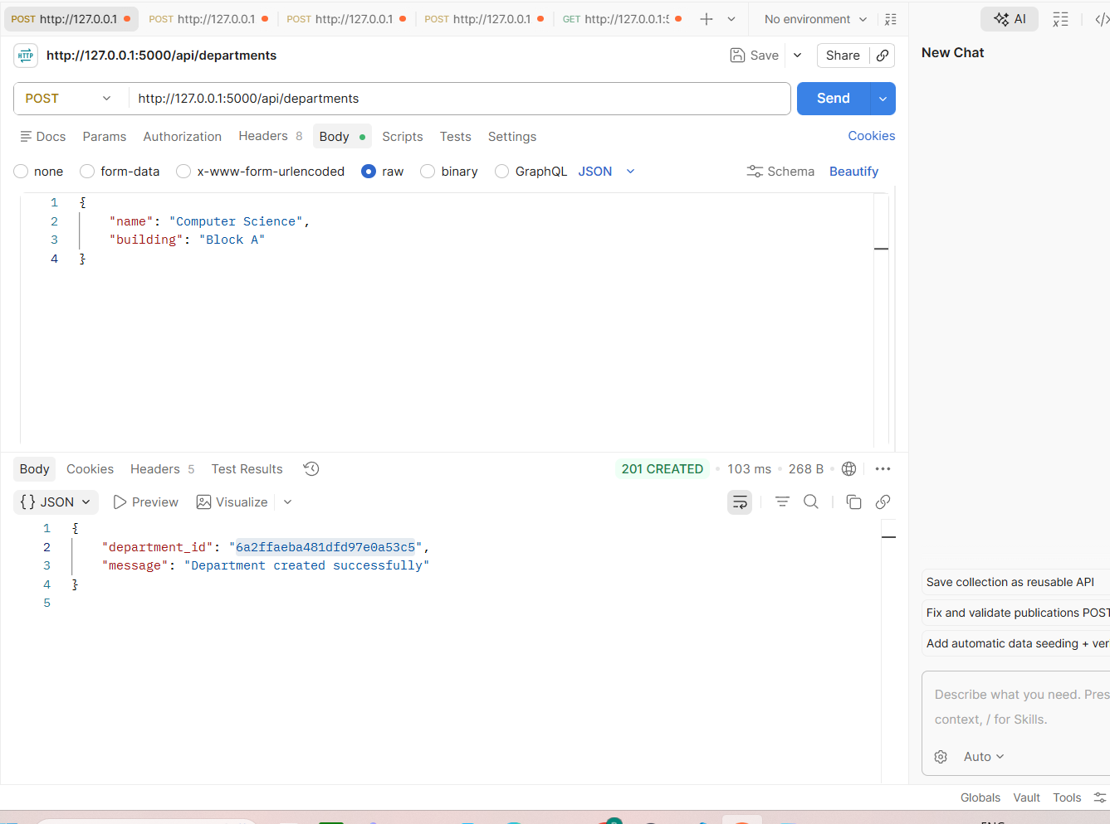

Staff
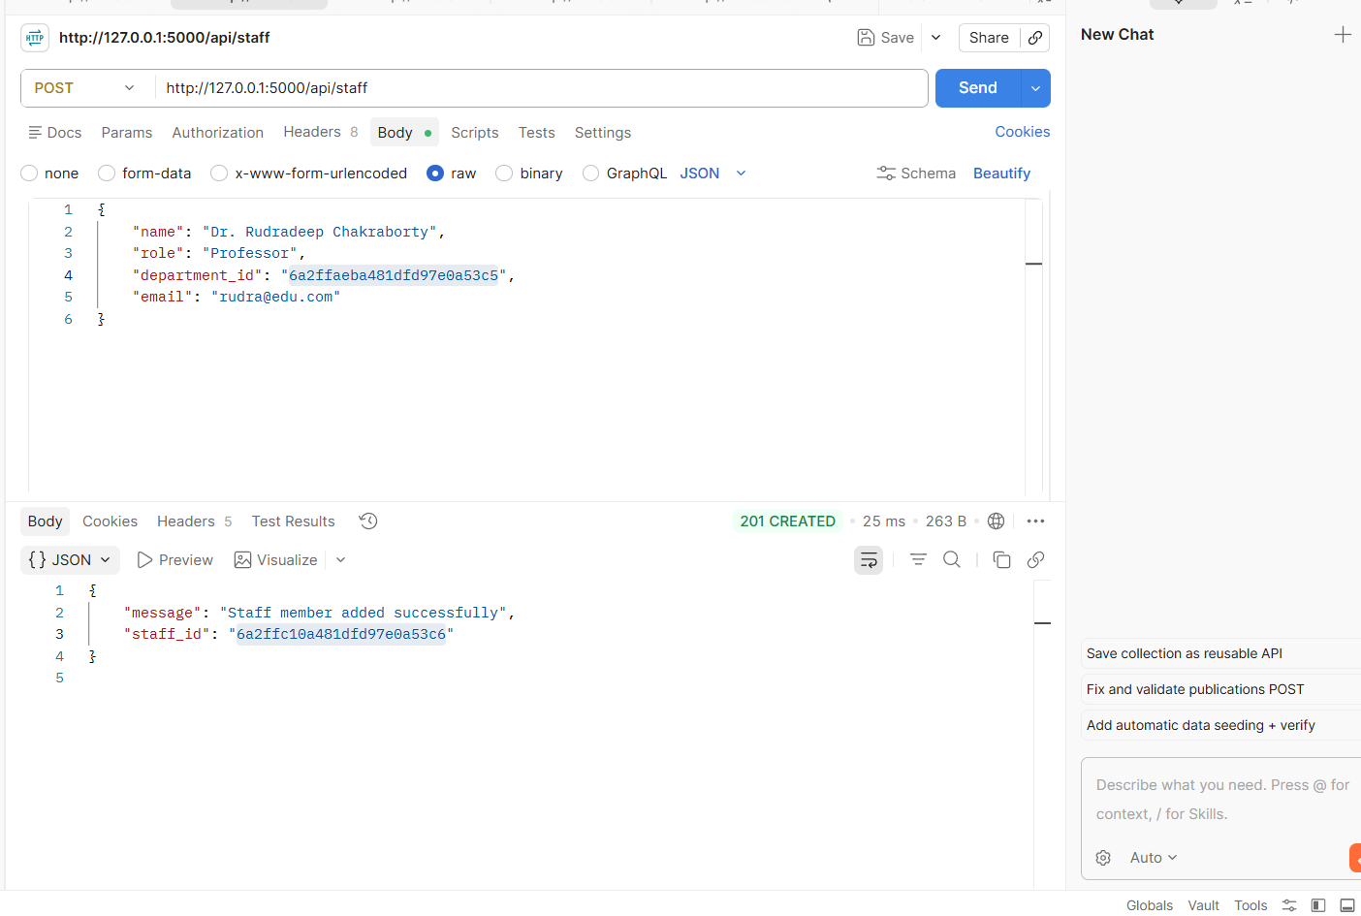

STUDENTS
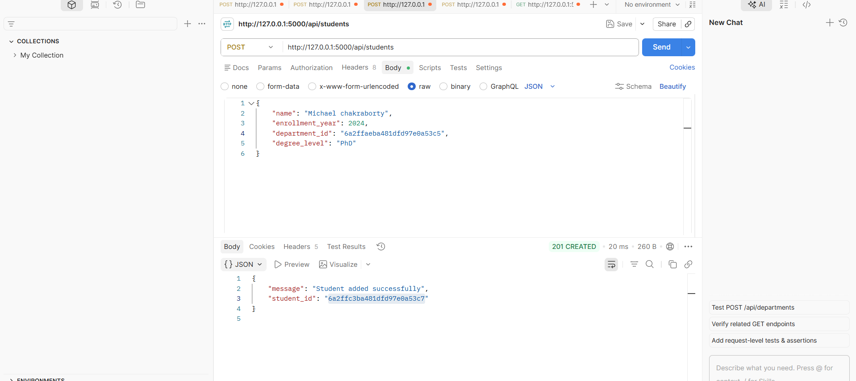

PUBLICATION
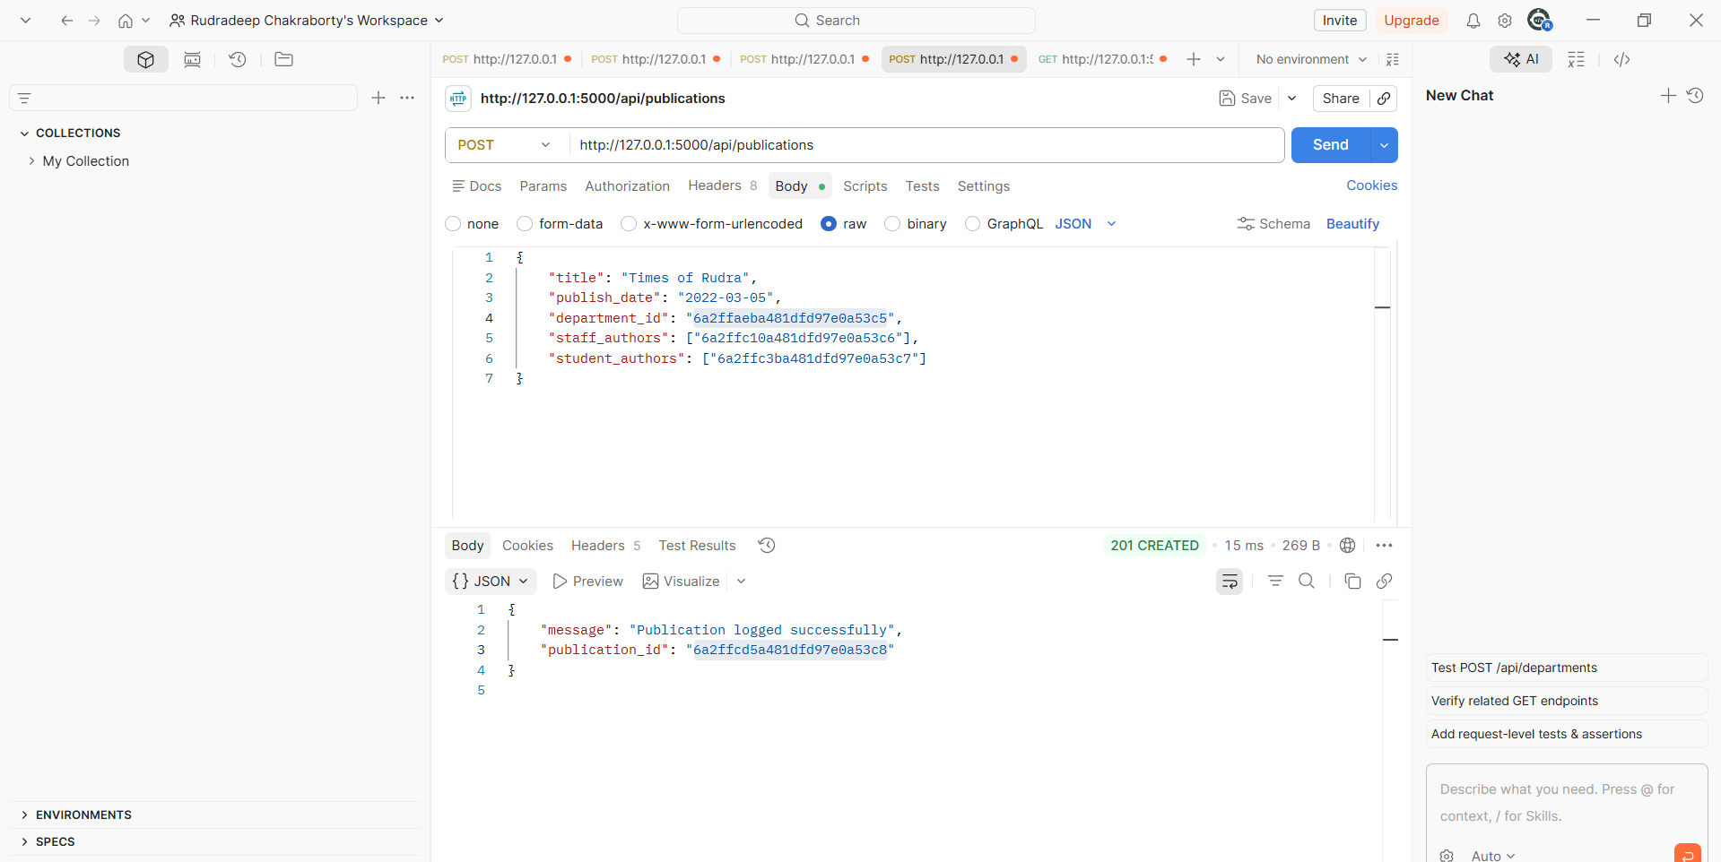
IMPLEMENTATION OF GET MODULE:
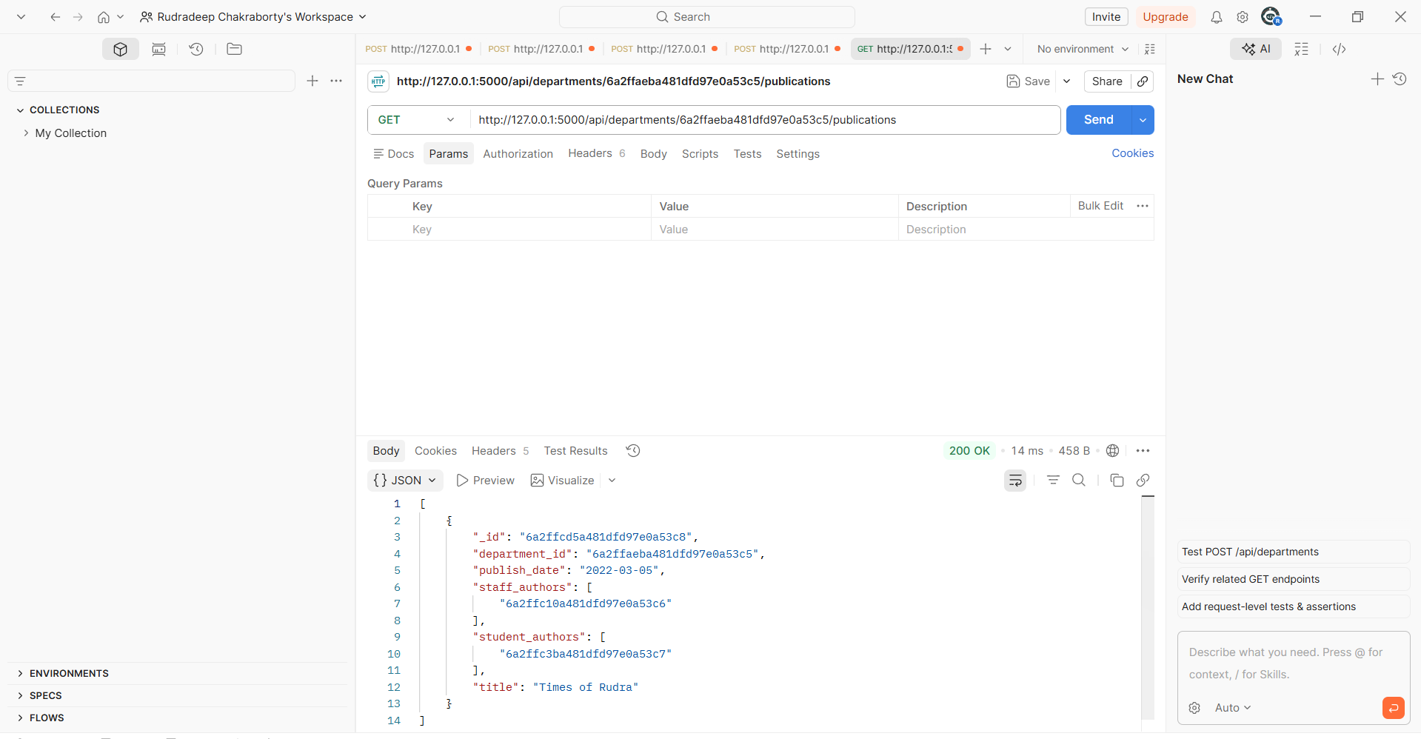

PYTHON PROGRAM RUNNING:
